**SQL Assignment 1**

1. What is a relational database management system (RDBMS)? What are the advantages of a database management system over a file system?
2. In a database management system, explain the ACID properties.
3. Explain the concept of normalization.
4. Explain the many types of query languages used in relational databases. DQL, DML, DCL, and DDL are some examples.
5. What is the difference between the main key and a composite key? Give instances of how primary key and composite are used.
6. Create a table with a primary key, a column default value, and a column unique constraint in SQL.

**ANSWERS**

**1.**RDBMS: It is an organised collection of data that have predefined relationships. These data are stored in one or more tables(which consist of rows and columns).

SQL is used to communicate with DBMS.

Multiple users can’t simultaneously use data in file system.

But, we can access, alter or delete these data simultaneously electronically using DBMS.

2.

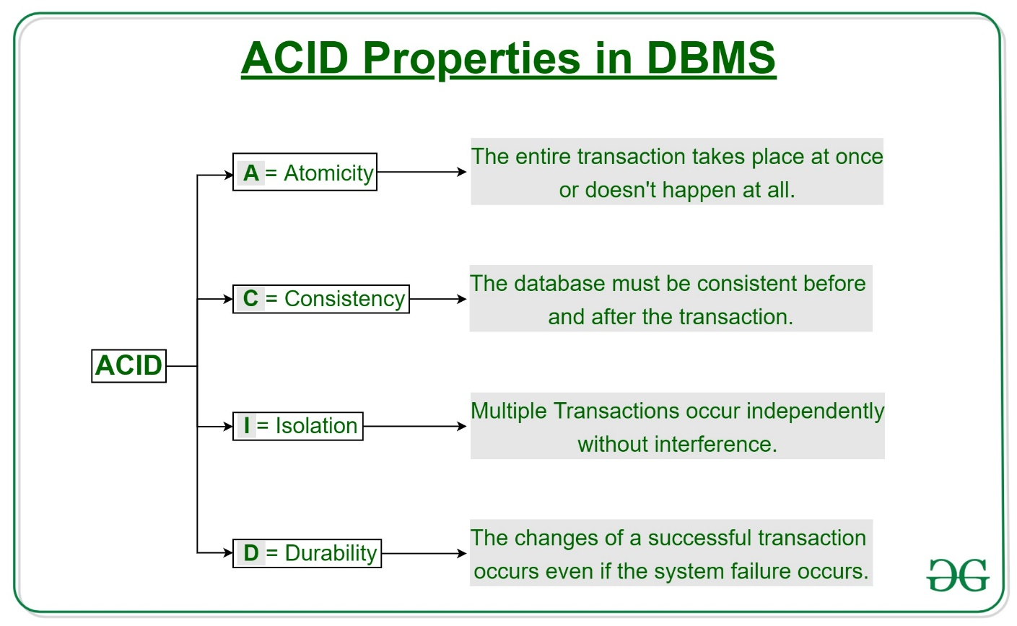

**anced - Learn It All!**

3. Normalization is the process to eliminate data redundancy and enhance data integrity in the table. Redundancy of data means there are multiple copies of the same information spread over multiple locations in the same database. Normalization also helps to organize the data in the database. It is a multi-step process that sets the data into tabular form and removes the duplicated data.

The drawbacks of data redundancy include:

Data maintenance becomes tedious – data deletion and data updates become problematic

It creates data inconsistencies

Insert, Update and Delete anomalies become frequent. An update anomaly, for example, means that the versions of the same record, duplicated in different places in the database, will all need to be updated to keep the record consistent

Redundant data inflates the size of a database and consumes more space on disk.

4. DQL: Data Query Language is used to query the Database.

SELECT keyword is used for querying .

DDL: Data Definition Language is used to define the data.

CREATE,ALTER, DROP are the keywords for DDL.

DML: Data Manipulation Language is used to tbring some changes in theDatabase.

INSERT,UPDATE, DELETE are the keywords for DML.

DCL: Data Control Language is used to control the database. This operation is restricted to database administrator .

GRANT,REVOKE are the keywords for DCL.

5.